- Ally received the following marks on her four math tests: 87, 93, 89, and 88. What mark must she receive on her last test to get have a 90 average of all five tests? (2 marks)

- The mean of five number is 27. If one of the numbers is excluded, the mean gets reduced by 2. Determine the excluded number. (2 marks)

- The rates of return on investment earned by a pharmaceutical company for four successive years were 1.5%, 10%, 14%, and 35%. What is the geometric mean rate of return on the investment by this company? (2 marks)

- Number of Cavities In a dental survey of third-grade students, this distribution was obtained for the number of cavities found. Use the weighted mean to find the average number of cavities for the class (2 marks).
Number of students X | Number of cavities f | X * f
12 | 0
8 | 1
5 | 2
5 | 3
Total 30

Weighted Mean (Avg # cavities) = ________________
- The following table shows the number of TV’s household in a sample of 50 households. Compute the mean, median, mode.
Number of TVs in the Household | Frequency (ƒ) | Cumulative Frequency
0 | 0
1 | 5
2 | 19
3 | 16
4 | 6
5 | 3
6 | 1

- The mean (1 marks) _____________

- The median (1 marks) ___________

- The mode (1 marks) ___________

- Which do you think is the better Measure of Central Tendency? Why? (2 marks)
________________________________________________________________________________________________________________________________________________________________________________________________________________________

- Comment on the skewness and the shape of the distribution (2 mark)
________________________________________________________________________________________________________________________________________________________________________________________________________________________

- The average price of a used car in 1967 can be represented by a bell-shaped distribution which has a mean of $1400 and a standard deviation of $150. Use the empirical rule to answer the following questions: use the graph in (d) to assist as it’s for marks too:

- What percent of the students will have a score between 1250 and 1550? (1 marks)

- Randomly selected students will have a 95% chance of having scores fall between what two values? (1 marks)

- Randomly selected students will have a 99.7% chance of having scores fall between what values? (1 marks)

- Label this normal distribution on the graph below with the data (above). Be sure to include the mean and all three (3) standard deviations (percentages and real numbers). (2 marks)
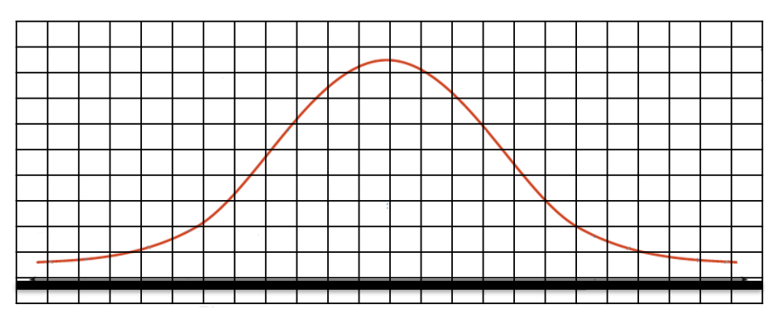

- A botanist measured the lengths of 15 common dandelions and found the following data in centimeters (cm). Calculate P₁₀ and P₉₀ and determine the 10-90 percentile range. 28, 31, 35, 25, 27, 28, 36, 40, 42, 45, 20.0, 21, 21, 21, 23

P₁₀ = ___________ (2 marks)
P₉₀ = ___________ (2 marks)
10-90 Percentile Range = _____________ (1 mark)
- The temperatures of Lake City were recorded over a 6 day period from July 1-6, 1882:
Lake City (ºC): 37.8, 38.0, 36.8, 36.9, 37.0, 37.2 Use the table below for assistance.
Lake City Temp (ºC) | $$\overline{x}$$ | $$(x-\overline{x})$$ | $${(x-\overline{x})}^{2}$$
total |  | 0

- Calculate the range of temperatures. ______ (1 mark)
- Calculate the mean temperature. ______ (1 marks)
- Calculate the standard deviation using the table above to assist __________ (5 marks)

- The ages of a sample of 40 applicants for a class are grouped into the following frequency distribution. Use the table below to assist in finding the mean, median, & modal class.

Age | Frequency (ƒ) | Midpoint | Weighted Class Midpoint | Cumulative Frequency
20 to under 22 | 4
22 to under 24 | 7
24 to under 26 | 10
26 to under 28 | 14
28 to under 30 | 3
30 to under 32 | 2
Totals
(2 marks each)
Mean = _________ Median = _________ Modal Class = ___________

